 

**Placement Empowerment Program**

***Cloud Computing and DevOps Centre***

60 Days of DevOps Challenge

***Day 2: Linux Shell Scripting & Automation***

***Name: Mary Edlyn A Department: CSE***



This Proof of Concept (PoC) demonstrates the Linux Basics Shell Scripting, Managing Processes, Using Package Managers, Basic Networking Commands and Editing Configuration Files.

**Challenge 1**: **Write a simple Bash script that prints “Hello DevOps” along with the current date and time.**

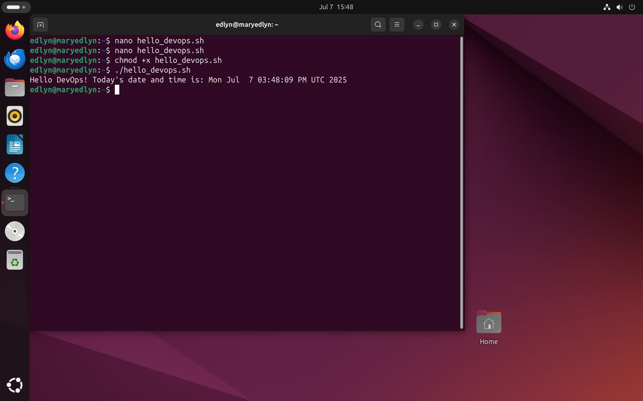

**Challenge 2**: **Create a script that checks if a website (e.g., https://www.learnxops.com) is reachable using curl or ping. Print a success or failure message.** 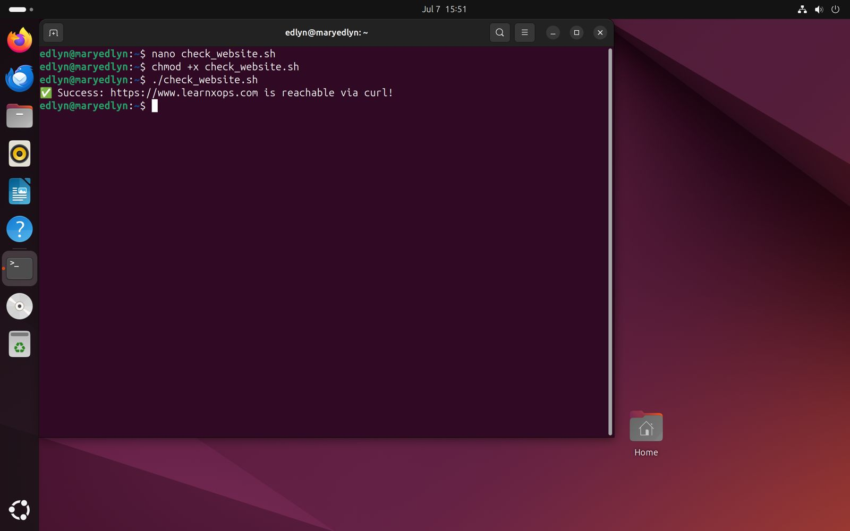

**Challenge 3: Create a script that lists all running processes and writes the output to a file named process_list.txt.**

0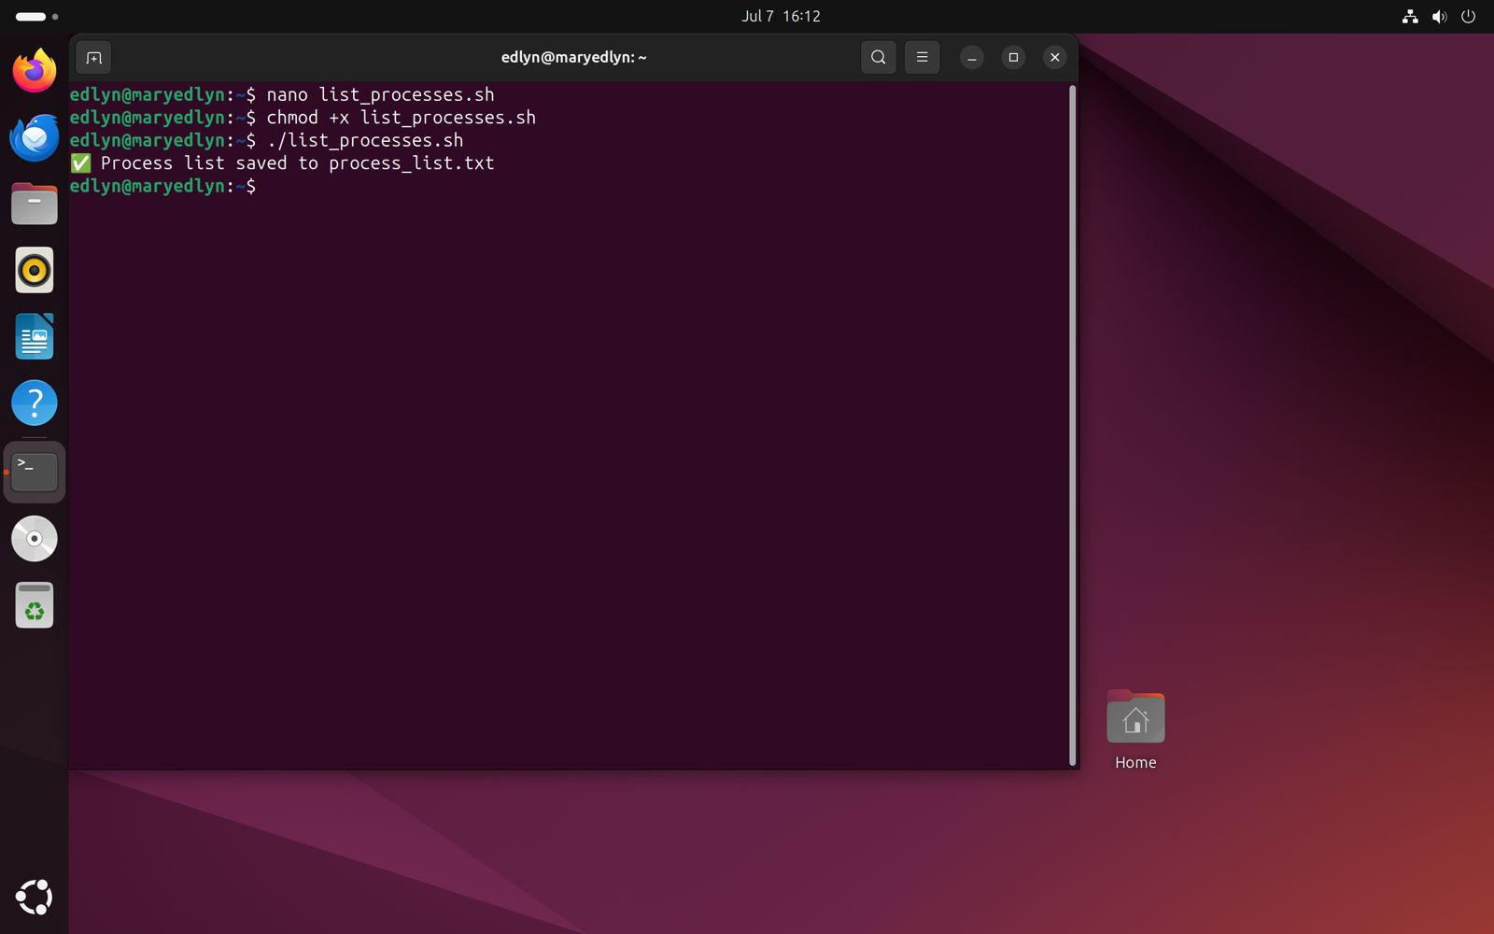

**Challenge 4**: **Write a script that installs multiple packages at once (e.g., git, vim, curl). The script should check if each package is already installed before attempting installation.** 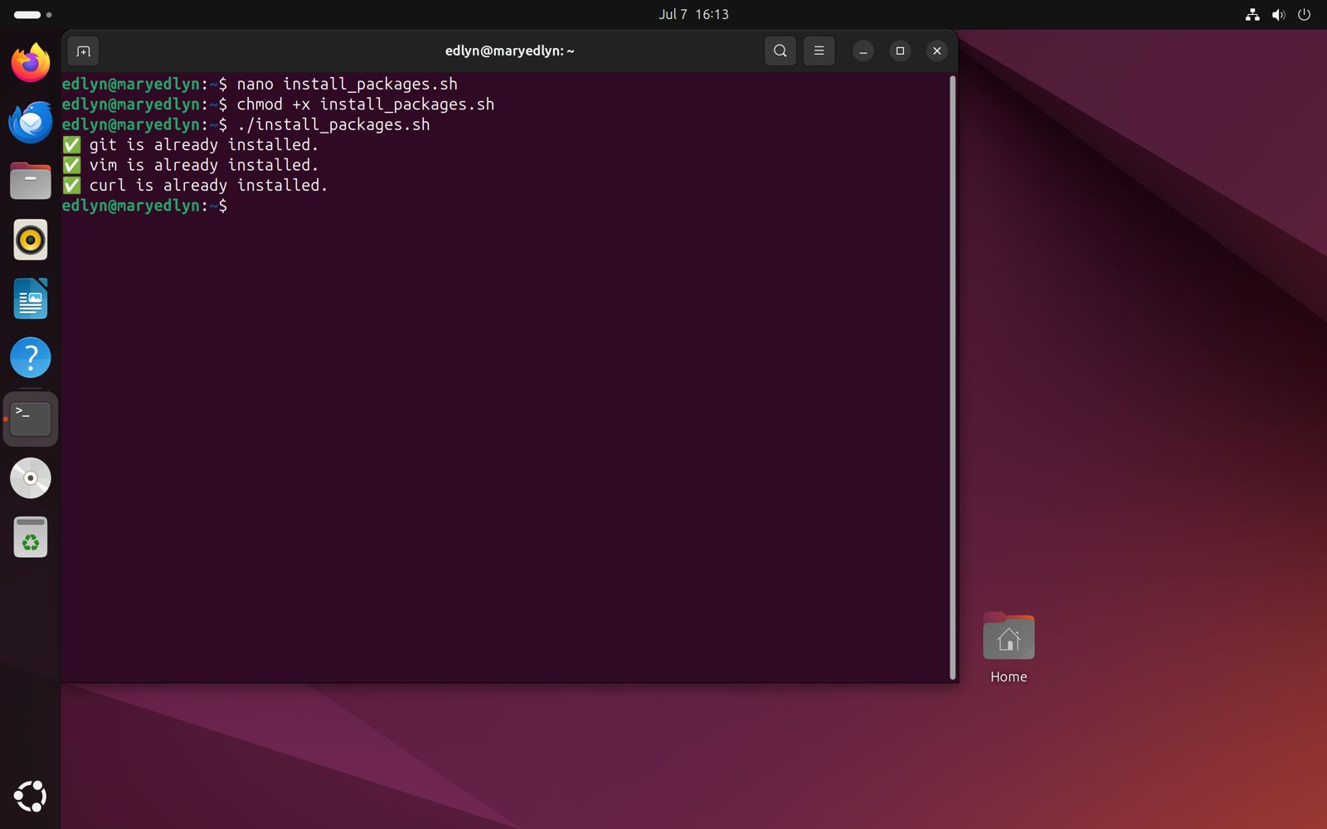

**Challenge** 5: Create a script that monitors CPU and memory usage every 5 seconds and logs the results to the file.

. 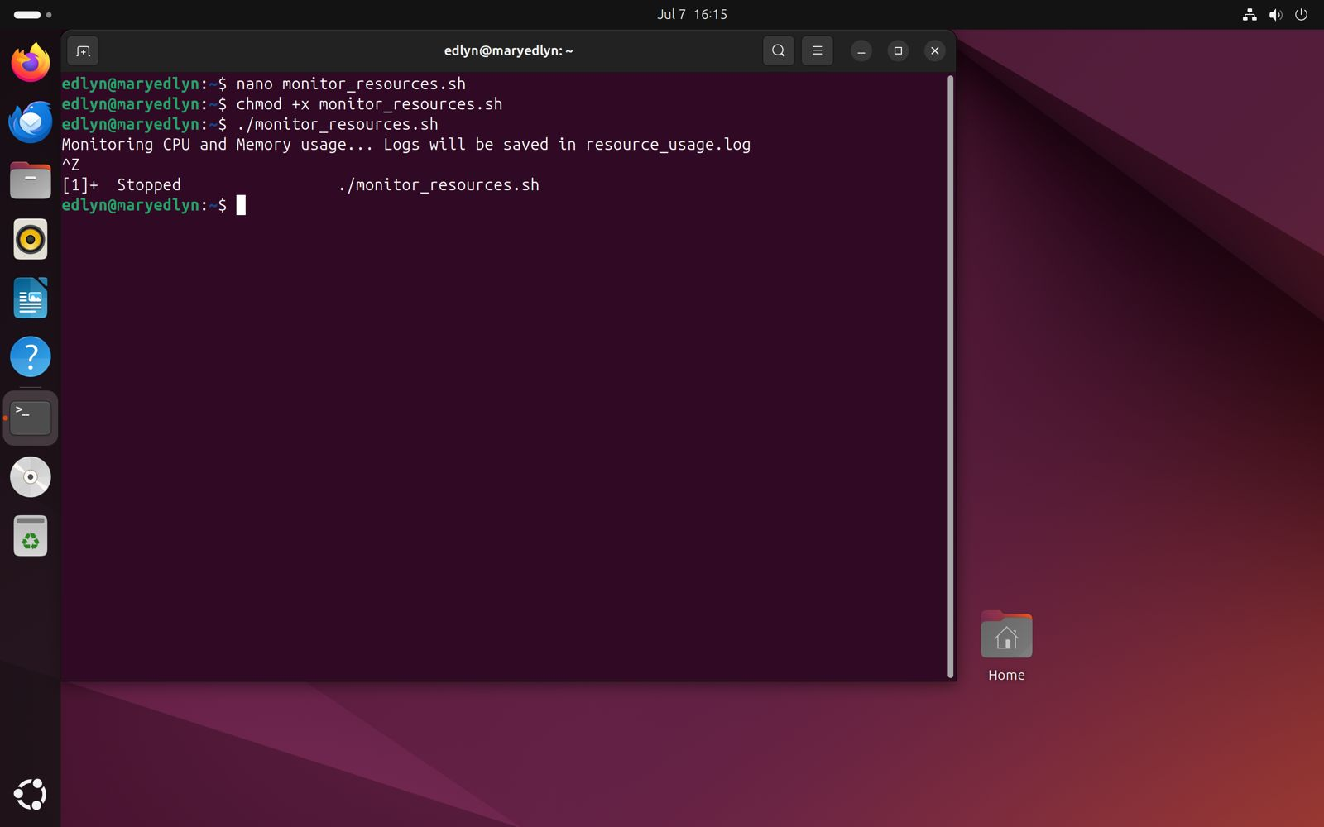

**Challenge 6**: **Automate user account creation – Write a script that takes the username as an argument, checks, if the user exists, gives the message “user already exists“ else creates a new user, adds it to a “devops“ group, and sets up a default home directory.**

